**Course Two**

# Get Started with Python

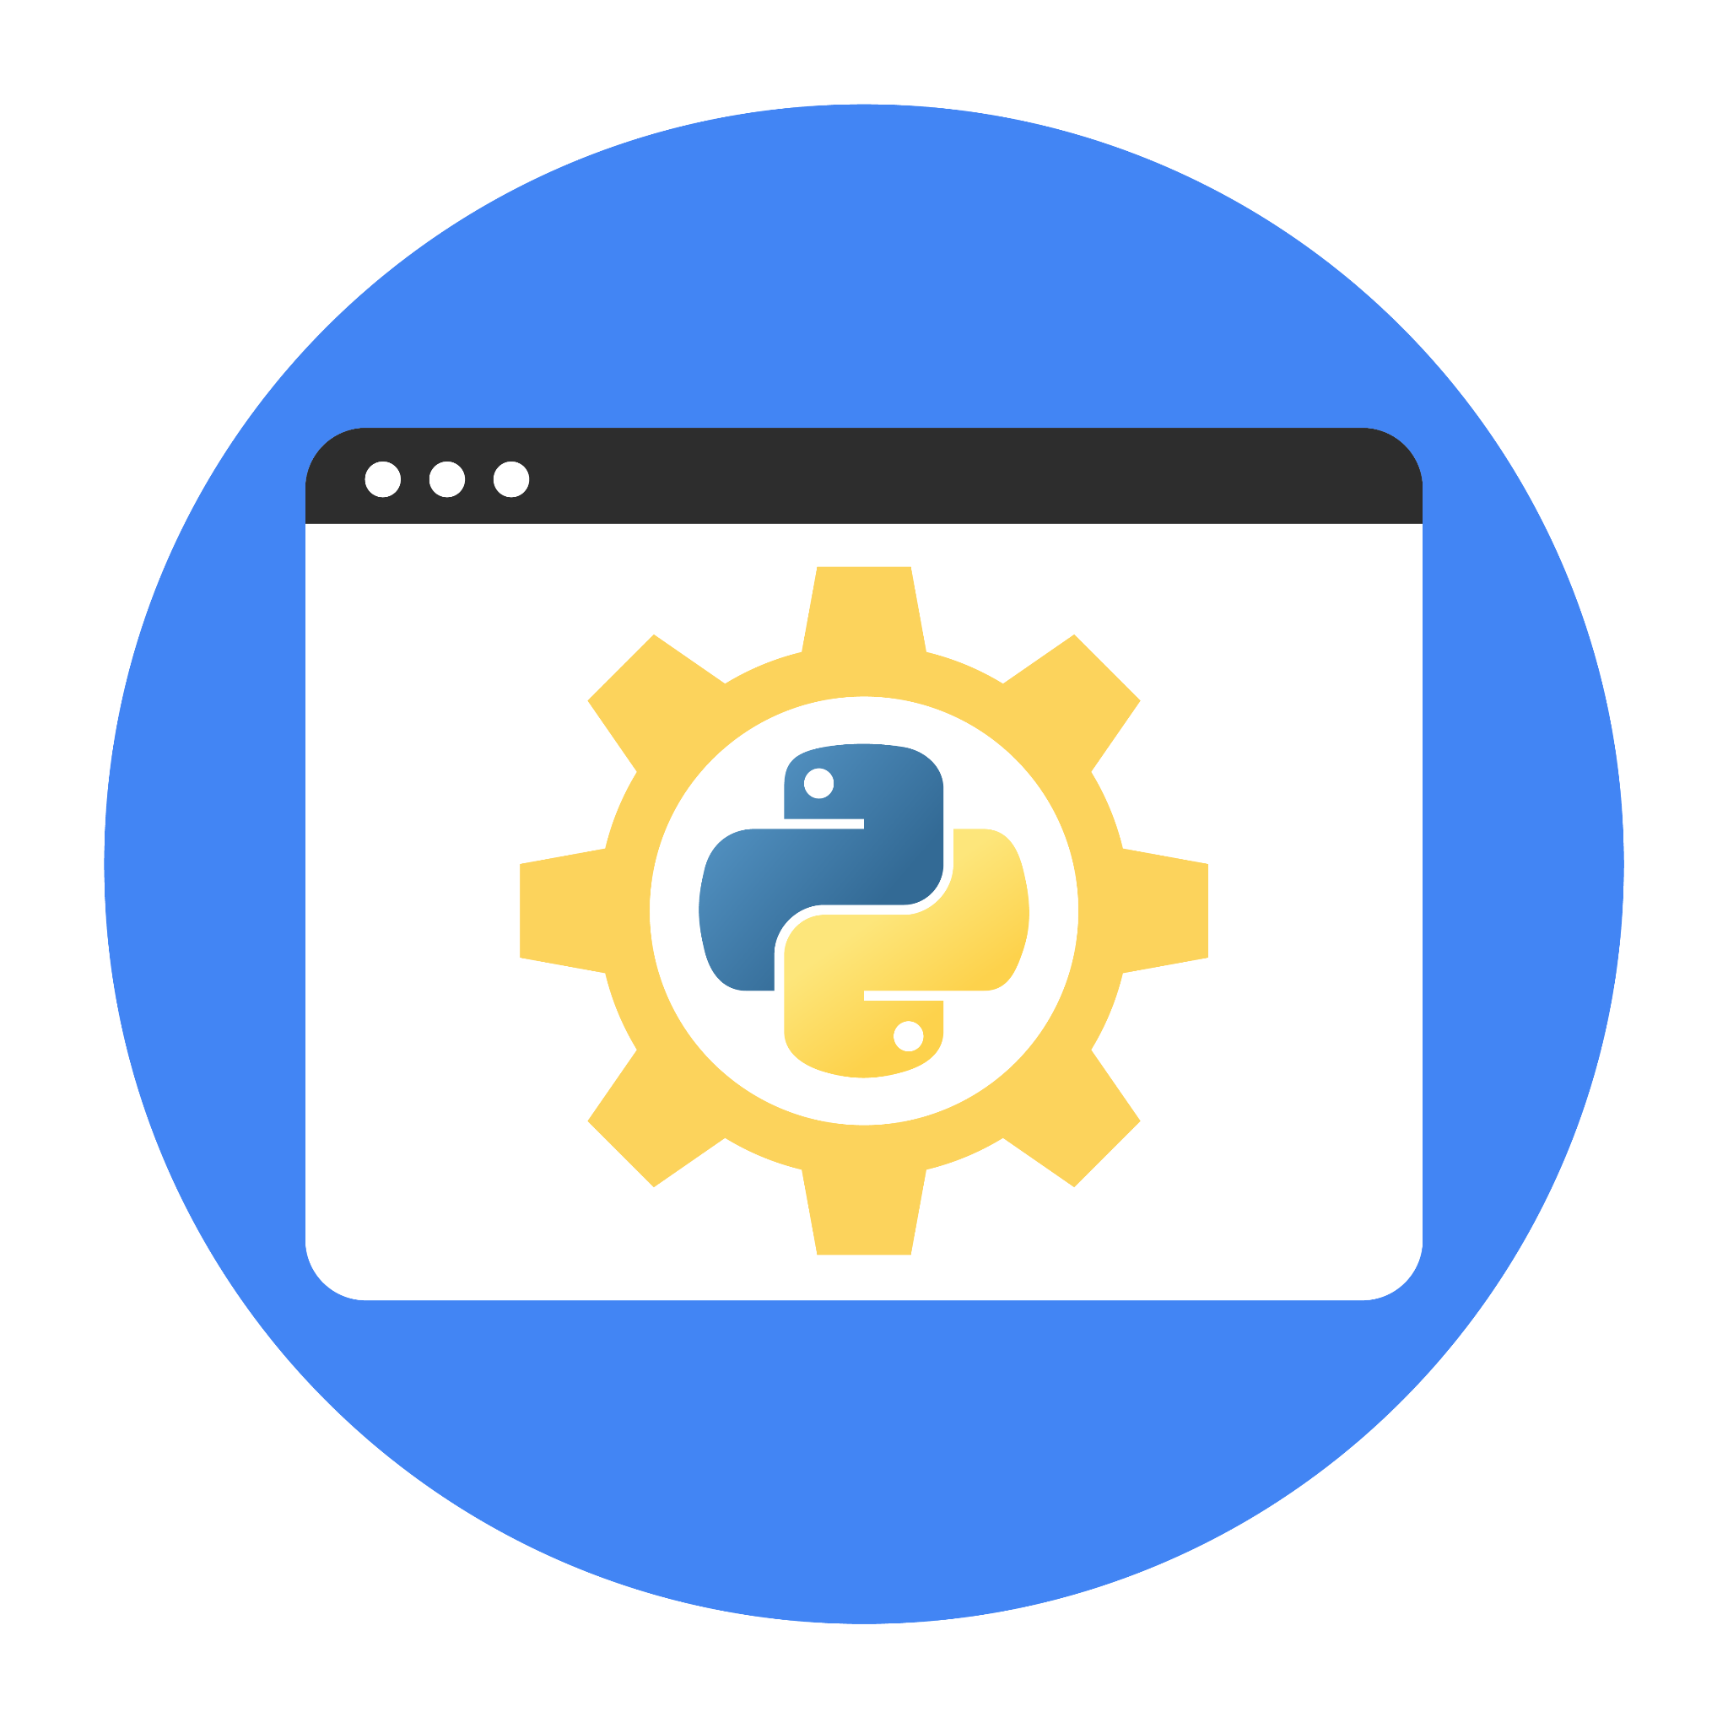

# Instructions

Use this PACE strategy document to record decisions and reflections as you work through this end-of-course project. You can use this document as a guide to consider your responses and reflections at different stages of the data analytical process. Additionally, the PACE strategy documents can be used as a resource when working on future projects.

# Course Project Recap

Regardless of which track you have chosen to complete, your goals for this project are:

* Complete the questions in the Course 2 PACE strategy document
* Answer the questions in the Jupyter notebook project file
* Complete coding prep work on project’s Jupyter notebook
* Summarize the column Dtypes
* Communicate important findings in the form of an executive summary

# Relevant Interview Questions

Completing the end-of-course project will help you respond these types of questions that are often asked during the interview process:

* Describe the steps you would take to clean and transform an unstructured data set.
* What specific things might you look for as part of your cleaning process?
* What are some of the outliers, anomalies, or unusual things you might look for in the data cleaning process that might impact analyses or ability to create insights?

**Reference Guide**

This project has three tasks; the visual below identifies how the stages of PACE are incorporated across those tasks.



**Data Project Questions & Considerations**

**PACE: Plan Stage**

* How can you best prepare to understand and organize the provided information?

To prepare to understand the given information the following steps can be followed: -

1. Understand the meaning of the observations and fields.
2. Understand the format of the given data.
3. Understand the size of the dataset.
4. Follow the goal description given in the tasks.

* What follow-along and self-review codebooks will help you perform this work?

Jupyter notebooks, self-learning modules

* What are some additional activities a resourceful learner would perform before starting to code?

Python basics revision, libraries that are provided to perform calculations on data frames, data dictionaries, statistical basics such as mean, median, quartiles etc.

**PACE: Analyze Stage**

* Will the available information be sufficient to achieve the goal based on your intuition and the analysis of the variables?

Yes, the available dataset is sufficient to perform the operations as are required to address the tasks.

* How would you build summary dataframe statistics and assess the min and max range of the data?

It can be done using the describe function of the pandas library in python.

* Do the averages of any of the data variables look unusual? Can you describe the interval data?

The averages of small numerical fields are in the interval of 0.3-2.9. The numerical fields fare_amount and total_amount have higher average of 13.03 and 16.31.

**PACE: Construct Stage**

**Note**: The Construct stage does not apply to this workflow. The PACE framework can be adapted to fit the specific requirements of any project.

**PACE: Execute Stage**

* Given your current knowledge of the data, what would you initially recommend to your manager to investigate further prior to performing exploratory data analysis?

I would recommend investigating fields like Rate Codes, store and fwd flags, tolls amount, fare amount in different seasons of the year etc.

* What data initially presents as containing anomalies?

Data that is not collected from trusted sources.

* What additional types of data could strengthen this dataset?

Maybe the types of taxis would be interesting to investigate.